- Delete those employees who joined the company before 31 dec-82 while there dept location is ‘delhi’ or ‘mumbai’.
DELETE FROM employee
WHERE hiredate < '1982-12-31'
AND deptno IN (
SELECT deptno
FROM department
WHERE location IN ('delhi', 'mumbai')
);

- Display employee name, job, deptname, location for all who are working as managers.
SELECT empno, ename, job, sal, location
FROM employee E
JOIN department D
ON E.deptno = D.deptno
AND E.empno IN (SELECT DISTINCT mgr FROM employee);
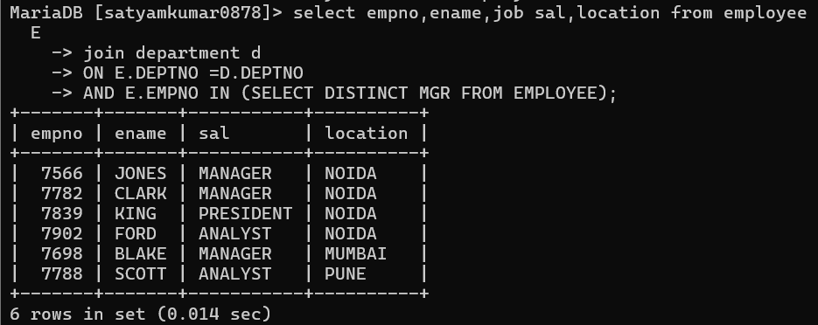
- Display name and salary of ford if his sal is equal to high sal of his grade.
SELECT EMPNO, ENAME, SAL
FROM EMPLOYEE
WHERE ENAME = 'FORD'
AND SAL = (
SELECT MAX(SAL)
FROM EMPLOYEE
WHERE GRADE = (
SELECT GRADE
FROM EMPLOYEE
WHERE ENAME = 'FORD'
)
);

- Find out the top 5 earner of company.
SELECT ENAME,SAL,SAL_RANK FROM (
SELECT ENAME,SAL,DENSE_RANK() OVER (ORDER BY SAL DESC) AS SAL_RANK FROM EMPLOYEE) T
WHERE SAL_RANK <=5;
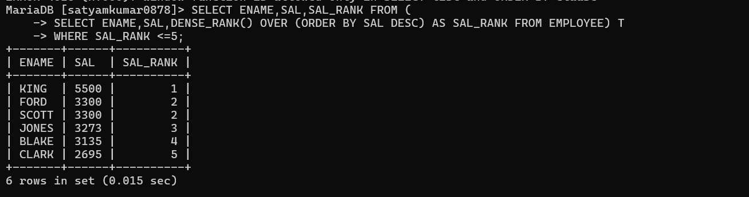

- Display the name of those employees who are getting highest salary.
SELECT ENAME,SAL FROM EMPLOYEE
WHERE sal = (SELECT MAX(sal) FROM employee);


- Display those employees whose salary is equal to average of maximum and minimum.
SELECT ename, sal
FROM employee
WHERE sal = (
(SELECT MAX(sal) FROM employee) +
(SELECT MIN(sal) FROM employee)
) / 2;


- Display dname where at least 3 are working and display only dname

SELECT dname FROM department d
JOIN employee e
ON d.deptno = e.deptno
group by d.dname
having count(*) >=3;

- Display name of those managers names whose salary is more than average salary of company.
SELECT ename
FROM employee
WHERE job = 'MANAGER'
AND sal > (SELECT AVG(sal) FROM employee);

- Display those managers name whose salary is more than an average salary of his employees.
SELECT m.ename
FROM employee m
WHERE m.job = 'MANAGER'
AND m.sal > (
SELECT AVG(e.sal)
FROM employee e
WHERE e.mgr = m.empno
);

- Display employee name, sal, comm and net pay for those employees whose net pay are greater than or equal to any other employee salary of the company?
select e1.empno,e1.ename,sal,comm,sal*IFNULL(COMM,0) AS NET_PAY FROM EMPLOYEE E1
WHERE sal + IFNULL(COMM,0)>ANY (SELECT SAL FROM EMPLOYEE E2 WHERE E2.EMPNO !=E1.EMPNO);
